University Of Engineering and Technology, Lahore Computer Engineering Department

Course Name: | Course Code: CMPE-112L
Assignment Type: | Dated: 16march2026
Semester: 1st | Session: spring
Lab/Project/Assignment #: 1 | CLOs to be covered: CLO1
Lab Title: while loop | Teacher Name: Hafiz Muhammad Mubashar

Lab Evaluation:

CLO1 | Apply appropriate programming techniques to create executable programs to solve well defined problems
 | Level1 | Level2 | Level3 | Level4 | Level5 | Level6
(5)
Total |  |  |  |  |  | /5

Rubrics for Current Lab Evaluation

Scale | Marks | Level | Rubric
Excellent | 5 | L1 | Submitted all lab tasks, BONUS task, have good understanding.
Very Good | 4 | L2 | Submitted the lab tasks but have good understanding
Good | 3 | L3 | Submitted the lab tasks but have weak understanding.
Basic | 2 | L4 | Submitted the lab tasks but have no understanding.
Barely Acceptable | 1 | L5 | Submitted only one lab task.
Not Acceptable | 0 | L6 | Did not attempt

LAB No 3
Lab Goals/Objectives:


Understand the working of while loops. Learn condition-based repetition.


Create programs using indefinite loops. Understand loop control.




Equipment Required: Computer/Laptop Python IDE
Python Interpreter

Theory:
A while loop executes a block of code repeatedly as long as a given condition remains true. The loop contains:
- A condition
- A statement block
- Updating value to avoid infinite loops
While loops are useful when the number of repetitions is not known before execution.

Lab Work:

Task 1
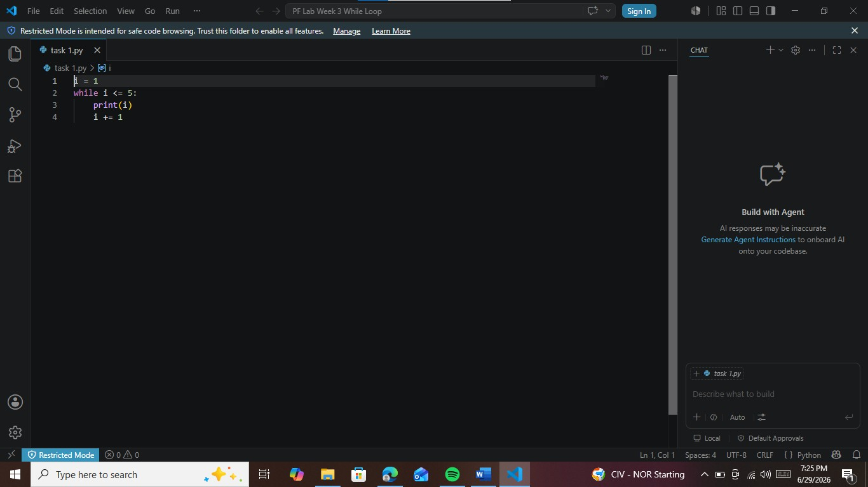
Write a python code to print numbers from 1 to 5 using a while loop.

Task 2
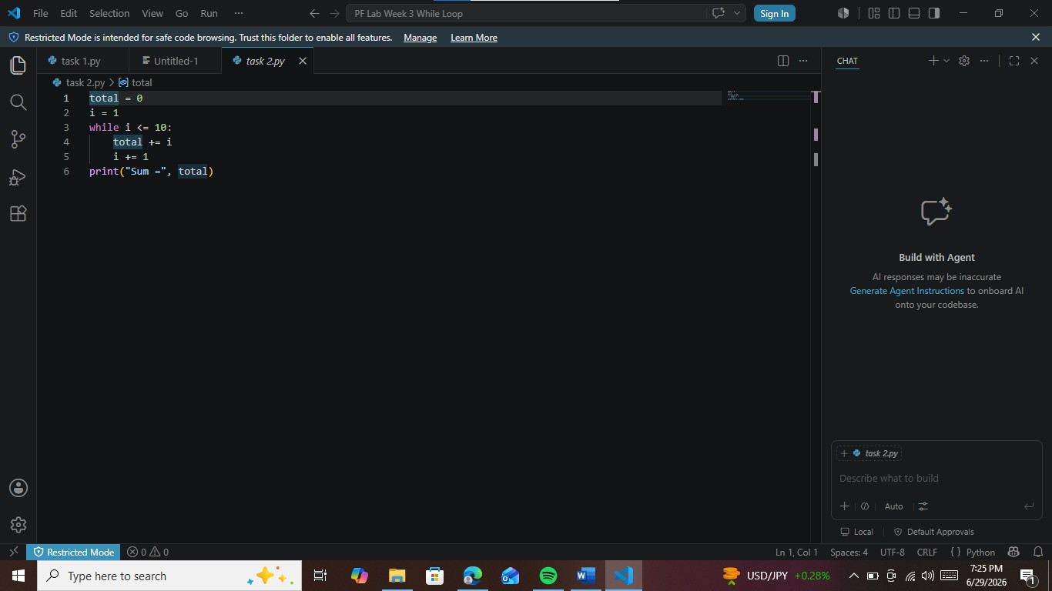
Write a python program to find the sum of numbers from 1 to 10 using while loop.

Task 3
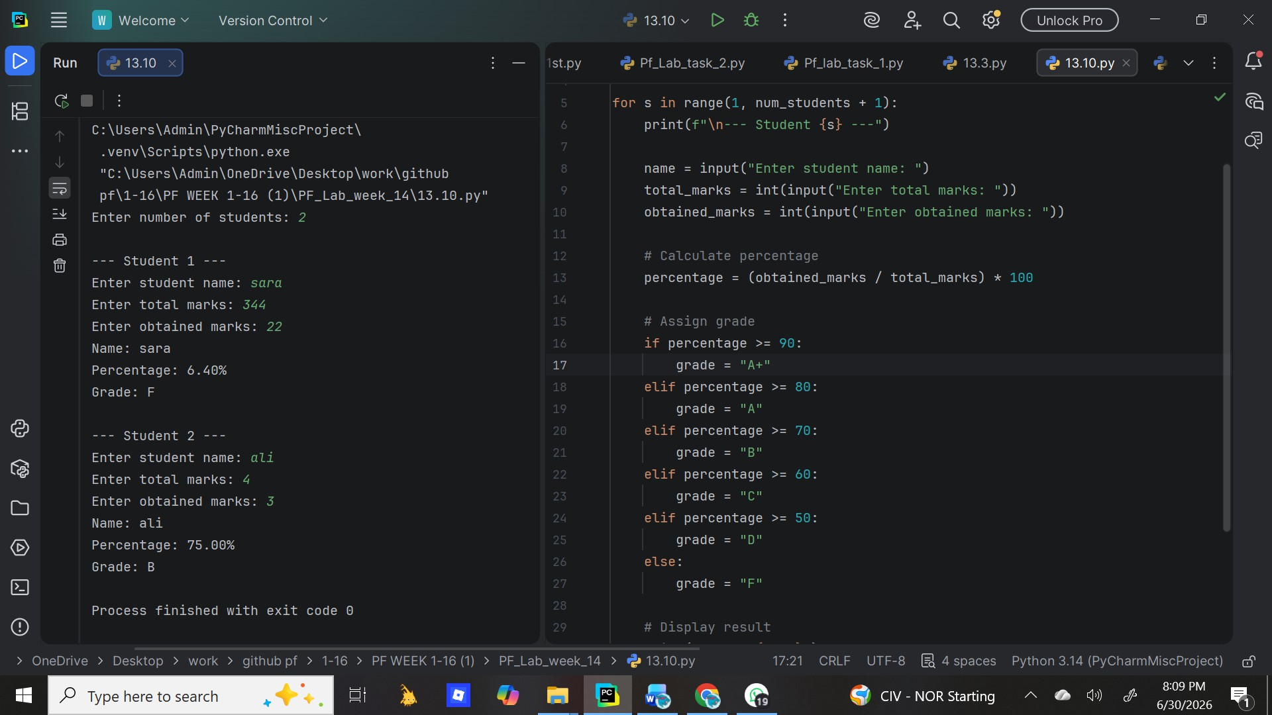
Write a python program to calculate percentage and assign grades for multiple students.

Task 4
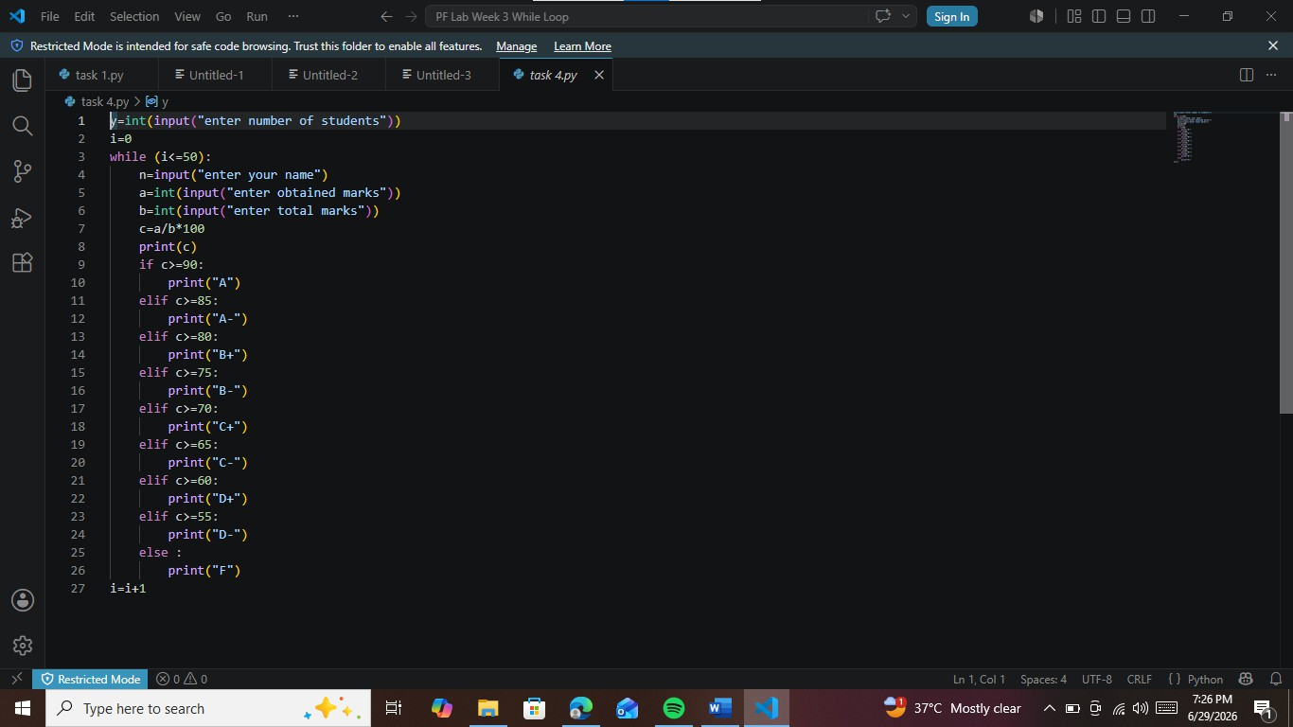
Write a python program to calculate percentage and assign grades to them.

Conclusions:
The while loop helps us repeat code as long as a condition is true.Unlike for loop which runs a fixed
number of times, while is used when we don’t know how many times we need to repeat.

